Numbers Determiners

🔢 What Are Numbers (Types of Determiners)?
# Source: AI Source: Provided by: [Data Path: Persons Table -> ID Column: 1, Name_En Column: Motasem Essam] -> From: [Chatgpt (GPT-4-turbo)] on [7/28/2025]
Number determiners are used to show how many or in what order things occur. They are divided into two main types:

✅ 1. Cardinal Numbers (Definite Quantity)
# Source: AI Source: Provided by: [Data Path: Persons Table -> ID Column: 1, Name_En Column: Motasem Essam] -> From: [Chatgpt (GPT-4-turbo)] on [7/28/2025]
Show how many of something there are.
These are basic counting numbers.
| Examples: one, two, three, four, five, etc.
|
🧾 Example sentences:
- She has three cats.
- I ate one sandwich.

✅ 2. Ordinal Numbers (Definite Order)
# Source: AI Source: Provided by: [Data Path: Persons Table -> ID Column: 1, Name_En Column: Motasem Essam] -> From: [Chatgpt (GPT-4-turbo)] on [7/28/2025]
Show the order or position of something in a list or sequence.
| Examples: first, second, third, fourth, etc.
|
🧾 Example sentences:
- He won first place.
- This is the third time I’ve called.

🔍 Summary Table:
# Source: AI Source: Provided by: [Data Path: Persons Table -> ID Column: 1, Name_En Column: Motasem Essam] -> From: [Chatgpt (GPT-4-turbo)] on [7/28/2025]
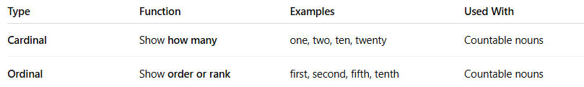
Type | Function | Examples | Used With
Cardinal | Show how many | one, two, ten, twenty | Countable nouns
Ordinal | Show order or rank | first, second, fifth, tenth | Countable nouns

⚠️ Note:
# Source: AI Source: Provided by: [Data Path: Persons Table -> ID Column: 1, Name_En Column: Motasem Essam] -> From: [Chatgpt (GPT-4-turbo)] on [7/28/2025]
- These are considered numeral determiners (a subtype of quantifiers or determiners depending on the grammar source).
- They are not adjectives when used directly to define a noun (e.g., three books, first runner).

